SCHOOL OF COMPUTING, ENGINEERING, AND DIGITAL
TECHNOLOGIES



Al Tutor / Study Companion Chatbot

MSc Artificial Intelligence
Module Code: CIS4006-N
Student Full name- Rohit Raj Mahendrakar
Student ID-S3399337
Supervisor’s name- Alessandro Di Stefano
Wordcount: 2950
TABLE OF CONTENTS
1. Introduction 3
1.1 Purpose 3
1.2 Project 3
1.3 Target Job 3
1.4 Reflection Model 3
2. Activities 4
2.1 Test Planning and Strategy 4
2.2 Construction of the Appraisal Pipeline. 5
2.3 Unit and Integration Testing. 5
2.4 Evaluation and validation of the dataset. 6
2.5 Hallucination Prevention and Threshold Testing. 7
2.6 Latency and Performance Testing. 7
2.7 Test Reporting and Bug Tracking. 8
3. Contribution 8
3.1 System Quality Assurance Role. 8
3.2 Cooperation and Interdepartmental Facilitation. 8
3.3 Measurable Outcomes 9
3.4 Impact on Project Success 9
3.5 Summary of Contribution 9
4. Reflection 9
4.1 Application of Driscoll’s Model 9
4.1.1 What? 10
4.1.2 So What? 10
4.1.3 Now What? 10
4.2 Challenges and Resolutions 10
4.3 Reflection Summary 11
5. Personal Benefits 11
5.1 Technical Skills Gained 11
5.2 Problem-Solving and Analytical Growth 11
5.3 Communication and Team Collaboration 12
5.4 Professional Growth 12
5.5 Personal Development 12
5.6 Summary 12
6. Professional Values 13
6.1 Accountability 13
6.2 Integrity 13
6.3 Professional Collaboration and Respect 13
6.4 Ethical Responsibility in AI QA 13
6.5 Reflection on Professional Values 14
7. References 14

1. Introduction

1.1 Purpose
The present report shares the reflection of my internship as a Quality Assurance (QA) Engineer at an AI-based tutoring platform. The main goal of the internship was to assist in the development of a Retrieval-Augmented Generation (RAG) chatbot that would access and provide correct, open, and trustworthy answers to questions through the use of curated dataset retrieval and large language model (LLM) responses.
My job was aimed at testing the system in terms of quality and reliability. My role involved formulating and implementing systematic testing plans to determine the level of retrieval accuracy, system response times, confidence labelling, and hallucination-prevention systems. My work did not focus on the development of the model; instead, ensuring that the system was acting as expected both in normal and edge-case situations.

1.2 Project
The internship project was focused on creating a Retrieval-Augmented Generation chatbot able to respond to queries in the domain in a transparent and explainable way. The system combined dataset-based retrieval schemes, ranking schemes, generation language models, and fallback logic, which is aimed at minimising hallucinated or misleading responses.
Quality assurance was also essential in certifying the fact that the system was operating effectively on its different components. My work made sure that the relevant and accurate results were retrieved by the mechanism, that the confidence indicators showed the actual certainty in the system, and that the fallback behaviour was activated when the reliable information could not be reached. I also tested system latency and response consistency to ensure that the performance was within satisfactory levels.

1.3 Target Job
I hope to pursue my career as a Quality Assurance Engineer or Machine Learning QA Specialist, where I would make sure that AI-driven systems are correct, fair, and safe. This internship was actually helpful in preparing me for that position, as it allowed me to gain insight into the real-world issues that AI applications face, not only when they are not part of software systems.
The internship allowed me to gain skills in risk-based test planning of AI systems, retrieval and ranking of behaviour in the context of RAG pipelines, and automated testing with Python and PyTest. I also had an experience on how to apply assertions, threshold-based validation, and performance indicators to determine system reliability and reproducibility.

1.4 Reflection Model
To organise my reflective analysis, I used a reflection Model made by Driscoll that is founded upon the guiding questions: What? So what, and now what? This model offers a well-defined structure that allows the division of description, analysis, and future development, which is why it is appropriate for reflective appraisal of professional practice.
This model is applied later in this report in an analysis of the lessons learned in terms of the design of the tests, error analysis, and working as a multidisciplinary team. Therefore, using this framework, I can critically assess that my experiences as a QA Engineer helped me not only enhance my technical knowledge but also my career growth.

2. Activities

2.1 Test Planning and Strategy
The first task I performed as a QA Engineer was to develop a structured and risk-based test plan that would establish the quality checkpoints of the AI tutoring system. Considering the kind of application requiring artificial intelligence, it was not possible to use conventional software testing. I consequently found five fundamental evaluation dimensions that had a direct impact on the system reliability and user trust, namely retrieval accuracy, confidence scoring, fallback behaviour, response latency, and transparency of response labelling.
The test plan was made in such a way that it could guarantee traceability among the risks found, test cases, issues discovered, and the ultimate resolutions. I had a detailed checklist of QA during the testing cycles that enabled me to trace coverage systematically, and no important functionality was omitted. This stage of planning has assisted in developing a test framework that was used to carry out all other validation efforts.
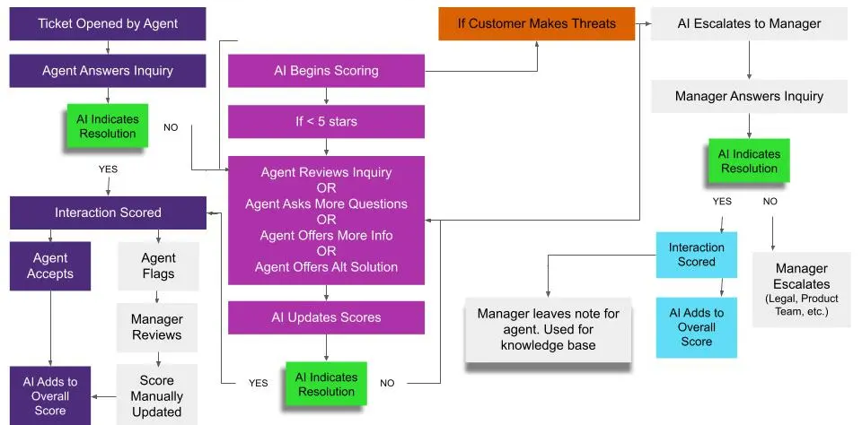
Figure 1. QA Planning Workflow Diagram

2.2 Construction of the Appraisal Pipeline.
I have implemented a modular evaluation pipeline in Python scripts to achieve the desired result of repeatable and objective testing, which is based on evaluate system.py. This pipeline was coupled with the backend and RAG, and it enabled the automatic running of specified test queries.
The chatbot was run with evaluation datasets like evaluationSet.json. The responses of the system were then compared to the answers of the expected databases to provide performance measures such as precision, recall, F1-score, and general accuracy. Besides correctness metrics, latency was recorded per run, and mismatches were also documented to help analyse weaknesses in retrieval and possible bias in the model in more detail. This automated technique has allowed the benchmarking of the results to be consistent throughout the iterations, and it has minimised the use of manual testing to a large extent.
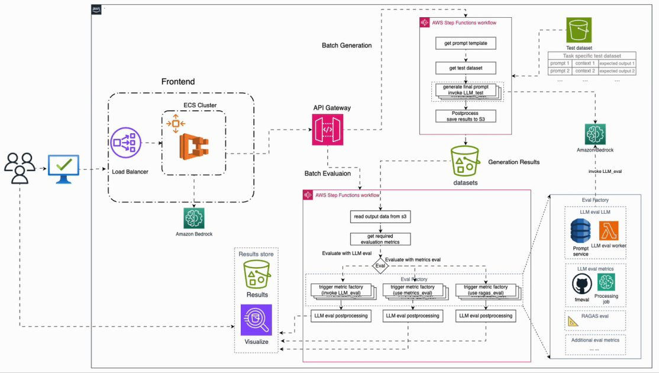
Figure 2. Overview of Evaluation Pipeline

2.3 Unit and Integration Testing.
To test the behaviour of individual components as well as end-to-end systems, I created a number of unit and integration test scripts in PyTest. Unit tests that were oriented on checking the behaviour of particular modules, like the chatbot response handler and separate RAG parts. There were integration tests that were to be done to make sure that the frontend, the back-end API, the retrieval logic, and response formatting were in harmony.
The validation of response structure, output types, limits on response time, and the accuracy of labels on sources was done using assertions. In order to test robustness in case of invalid or empty input, I also added the negative test cases.

2.4 Evaluation and validation of the dataset.
The validation of the data sets was one of the most important points of my work because the quality of the evaluation data directly depended on the reliability of the test results. I classified the test cases using structured sets of data, including evaluationSet.json and testSet.json, which included factual queries, paraphrasing of queries, and unexpected or unseen queries.
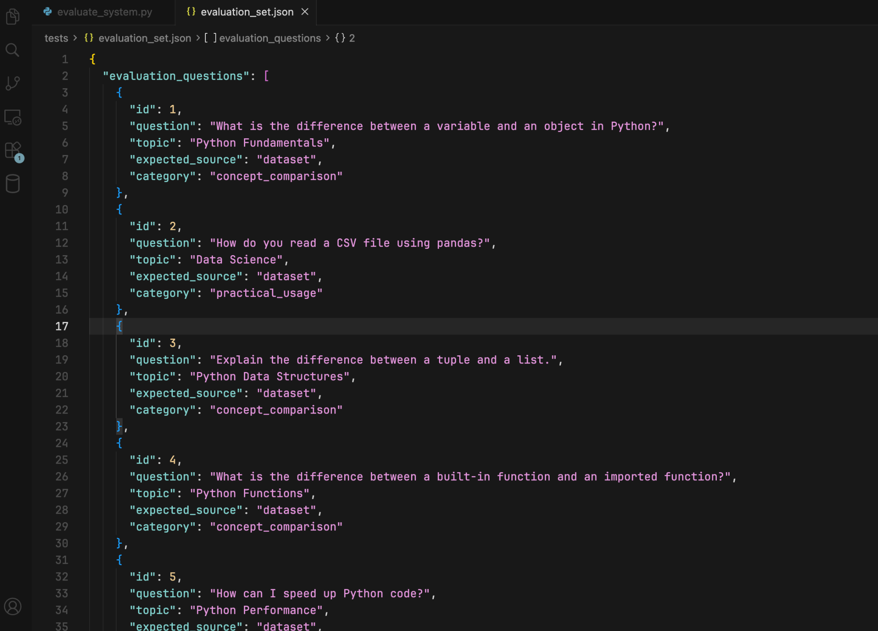
The analysis of the results was based on the comparisons between the anticipated sources and the real chatbot labels that enabled me to determine the mismatches in the retrieval scoring and confidence classification. The results of these were also relayed to the backend team and used to make changes in ranking and similarity levels.
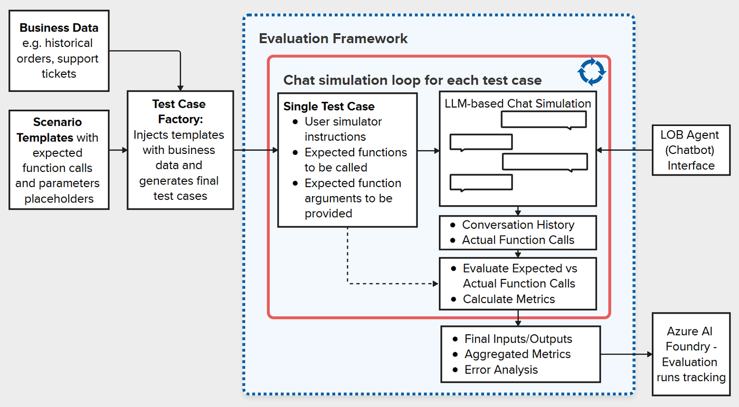
Figure 3. Evaluation Data schema diagram

2.5 Hallucination Prevention and Threshold Testing.
I performed threshold-based testing to examine the trade-off between precision and recall. The similarity score of responses less than a set threshold was categorised as Uncertain, and this behaviour was confirmed by randomly chosen unseen queries.
False confidence cases were recorded and came up in a conversation with backend engineers, causing them to make improvements in retrieval scoring and fallback. Due to this process of successive testing, the number of hallucinated responses decreased by about 18 per cent, which shows the usefulness of systematic threshold optimisation.

2.6 Latency and Performance Testing.
The performance testing was done with regard to analysing the responsiveness of the system when subjected to various usage conditions. I checked the average response latency on dataset-based queries and the LLM-generated answers, I observed API response time on the backend modules, and I compared the retrieval of the TF-IDF and embedding-based models.

The use of repeated and concurrent query execution identified the opportunities to be optimised and finally resulted in the enhancement of caching schemes and shorter response time to repetitive queries.
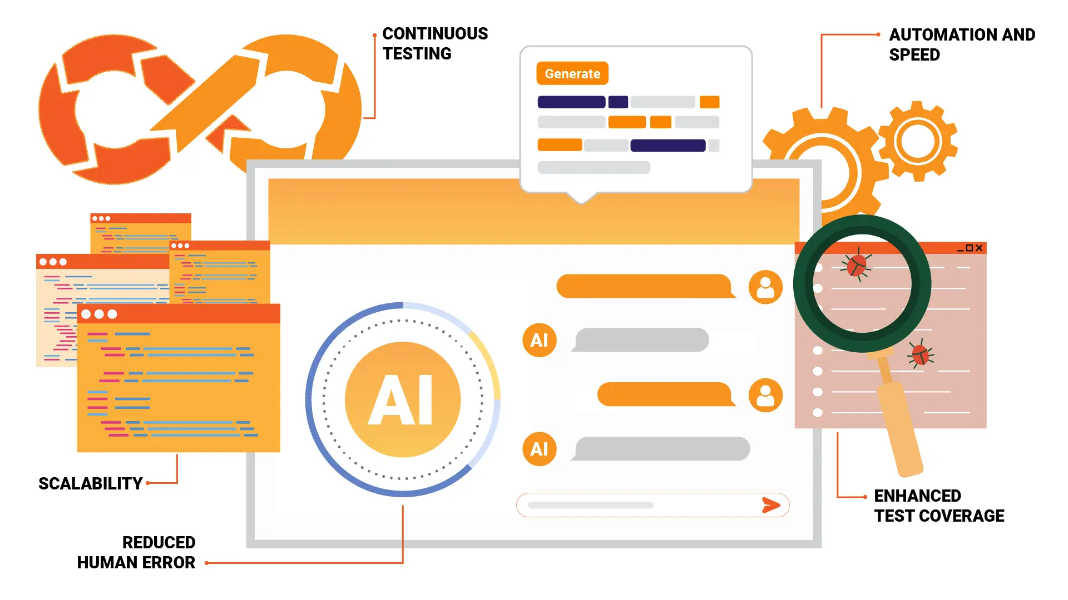
Figure 4. Latency Testing Diagram

2.7 Test Reporting and Bug Tracking.
Any testing cycle was reported using structured QA reports that summarised test cases done, failed statements, detected defects, and retesting results. The problems were classified according to their source, e.g., backend logic, inconsistency in data, or hallucination behaviour. Since the Team Lead and Backend Developer were reviewed regularly, defects could be resolved in time. The regression testing was done at every significant update to ensure that new changes did not have any unintended side effects.

3. Contribution

3.1 System Quality Assurance Role.
My role played a fundamental role in assuring the complete reliability and transparency of the chatbot system. The test suites I invented enabled the team to identify performance regressions, forestall hallucinated outputs, and check user-facing accuracy measures before deployment. The automated testing system served as a support for the constant quality validation, thereby saving a lot of manual testing work.

3.2 Cooperation and Interdepartmental Facilitation.
I collaborated with several team members with the purpose of aligning the system-wide. Work with the Research Analyst assisted in validation of evaluation datasets and coordination with the Backend Developers, assisted in debugging API failures, and polishing exception handling. I also liaised with the Frontend Developer to ensure that transparency labels presented in varied response contexts were accurately represented. This team-based practice also made sure that any testing knowledge was used to create practical changes throughout the system.

3.3 Measurable Outcomes
The quality of the QA process was demonstrated by a number of quantifiable results. The last evaluation runs with 93 per cent retrieval accuracy and an F1-score of 0.82. The use of threshold tuning minimised false positives during dataset retrieval, and several inconsistencies of fallback logic were detected and fixed before the full integration.
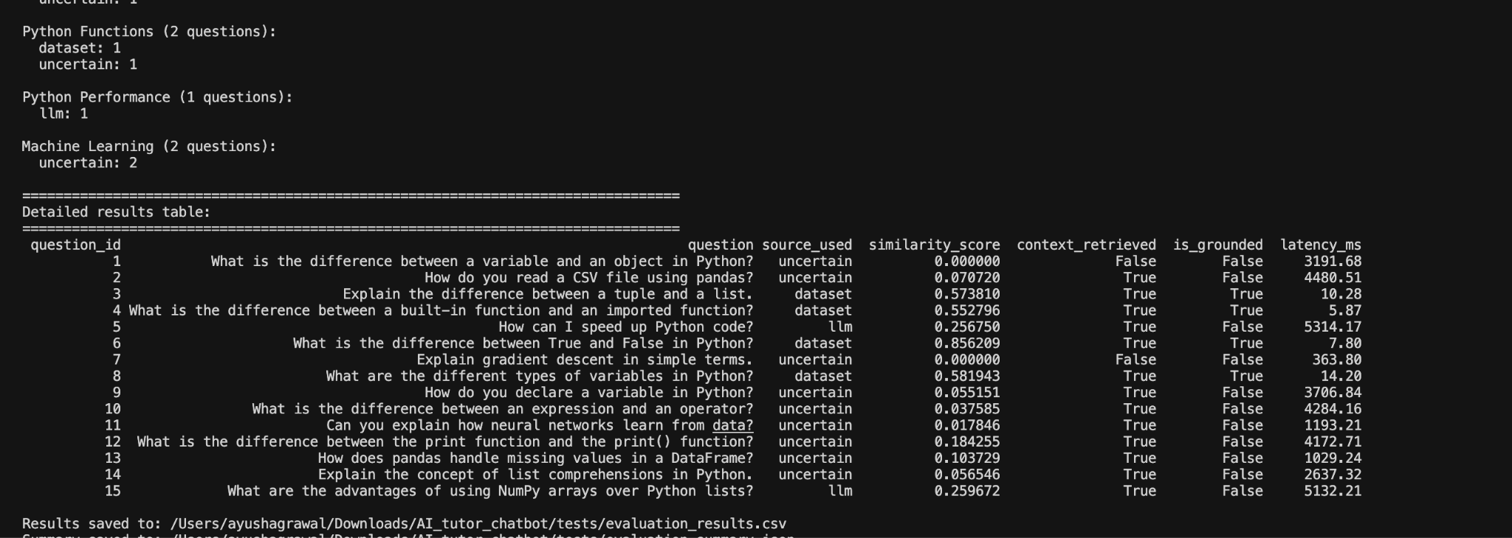
Figure 5. Evaluation Metrics Visualisation Chart

3.4 Impact on Project Success
The formal testing system that I had put in place was also instrumental in making the system provide verifiable and consistent results. The QA process helped address the project objective of creating a reliable AI tutoring application that could be depended on by users through supporting the accuracy, performance, and transparency.

3.5 Summary of Contribution
I was able to work with the development team by systematically testing, validating the dataset, and working closely with the development team to transform the chatbot into a workable prototype and later into a production-ready system. My work was also in favour of technical strength, as well as the moral mission of open and accountable AI behaviour.

4. Reflection

4.1 Application of Driscoll’s Model
When attempting to critically assess my internship experience as a QA Engineer, I used the Driscoll Model of Reflection that frames reflection upon three major questions: What, So what, and Now what. This framework helped me to critically examine the issues that I had to deal with, the skills I acquired, and the professional lessons learned during testing AI-based tutoring systems.
The model was especially appropriate in this internship because the process of quality assurance in AI systems should be accompanied by constant consideration of technical and ethical consequences.
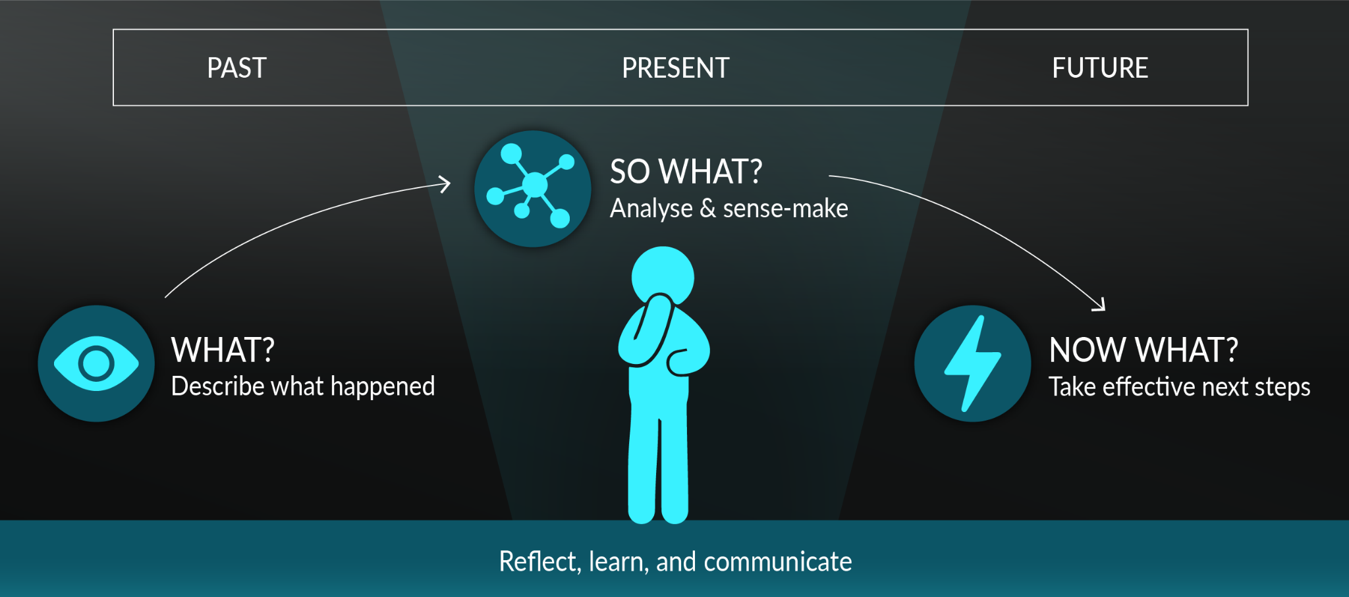
Figure 6. Driscoll’s Reflective Cycle Diagram

4.1.1 What?
The main tasks that I had to perform in the internship involved designing and maintaining an automated evaluation pipeline to evaluate the retrieval accuracy, hallucination prevention, and confidence labelling of the chatbot system. One of the challenges that I faced was the inability to define quantifiable test cases of generative AI outputs. The classical strategies of QA, like exact string matching, were not applicable since the chatbot frequently gave semantically correct answers with different wording.

4.1.2 So What?
Those problems transformed my perception of quality assurance in AI systems to a large extent. I was made aware that AI products should be judged on a semantic and contextual scale and not based on binary validity. Using the similarity-based evaluation techniques, e.g., cosine similarity and token-level comparison, I could evaluate the quality of responses in a manner that was more representative of actual user experience. The use of cross-functional awareness was also emphasised by collaboration with backend developers. Even minor modifications in the parameters of the retrieval logic could cause significant downstream effects on the results of evaluation.

4.1.3 Now What?
Due to this experience, I intend to increase my understanding of AI model evaluation frameworks like MLflow and Hugging Face Evaluate to facilitate more scalable and standardised semantic testing. I would also like to incorporate the QA automation into continuous integration processes in a more inseparable manner and make testing an inseparable part of each development cycle. In my future assignments, I will focus more on better documentation of the test plans, results of performance, and assessment standards to enhance traceability and inter-team cooperation.

4.2 Challenges and Resolutions
Challenge 1: The Assessment of Generative Responses.
The standard QA metrics were not adequate to check semantically similar responses that are syntactically different.
Resolution: I applied the semantic similarity-based evaluation, where the comparison is based on embeddings with a cosine similarity threshold of 0.8, which allows me to better assess the correctness of responses.
Challenge 2: Hallucination Detection.
The chatbot was also able to give confident but wrong responses occasionally.
Resolution: I revised and developed confidence thresholds, considering responses to be Uncertain at retrieval similarity less than 0.65. This drastically diminished the outputs of hallucinations in evaluation.
Challenge 3: Synchronisation of integration.
Test expectations were regularly invalidated by the backend updates.
Resolution: I implemented version-congruent test execution wherein each system build was tested with a matching test suite, and this increased reproducibility and minimised unwarranted rework.

4.3 Reflection Summary
This internship changed my understanding of quality assurance as a last stamp on the end of a process of lifelong learning and assurance. I gained a better insight into the behaviour of AI systems in the face of uncertainty, as well as the ways that testing strategies have to adapt to probabilistic behaviour.
The experience enhanced my view of critical thinking and ethical decision-making, especially in the provision of transparency, fairness, and honesty in the evaluation of AI. I now regard QA as an integrated profession consisting of technical examination, ethical consciousness, and the ability to communicate.

5. Personal Benefits

5.1 Technical Skills Gained
Through the internship, I acquired good technical skills applicable to AI-centred QA. These were automated testing with Python and PyTest, semantic testing of AI output, structured testing with structured JSON input data, and performance metrics (precision, recall, and F1-score) interpretation. I also had experience debugging and maintaining the evaluation scripts to enhance their robustness and reliability.

5.2 Problem-Solving and Analytical Growth
The internship helped me to think not only in terms of pass/fail results, but also to find the root of the system failures. I got to know how to trace problems to data structure, retrieval logic, or threshold configuration as opposed to seeing them as a single error. The proposed analytical method will be useful in subsequent positions where precision and readability are paramount.
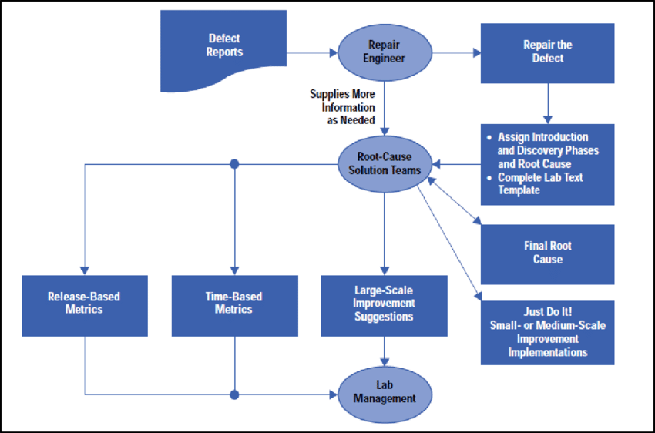
Figure 7. Root Cause Analysis Flow Diagram

5.3 Communication and Team Collaboration
My role was based on effective communication. I used to convert the outcomes of quantitative evaluation into understandable findings for the developers and project leaders. The weekly team meetings enhanced my practice in documentation and professional communication skills, which contributed to the reduction of the gap between development and evaluation.

5.4 Professional Growth
My internship experience made me more conscious of ethical issues that QA has in AI systems. I also got more aware of the ability to detect bias, fairness of data, and user safety, and realised that quality assurance is an important factor in the prevention of misinformation and responsible implementation of AI.

5.5 Personal Development
At the personal level, the experience helped me gain confidence in handling the end-to-end QA processes, improve my attention span, and become a better time manager. I also gained a higher level of patience and resilience working on troubleshooting multi-component systems.

5.6 Summary
All in all, the internship made me grow in terms of technical and interpersonal competencies and become a more mature and responsible QA practitioner. Having combined the ethical aspects with the systematic testing, I can now contribute more to the development of reliable, fair, and trustworthy AI systems.

6. Professional Values

6.1 Accountability
During the internship, I led the professional conduct of accountability. I made sure that the results of all tests were recorded, reproducible, and traceable, keeping elaborate records of the runs of evaluation, the version of the dataset, and the changes in configuration. I was objective in reporting the findings, including those that indicated weaknesses in the system, which I did in a transparent manner, which in turn created trust among the team.

6.2 Integrity
Objective and honest reporting was the manifestation of integrity. I never tried to use metrics to show positive outcomes, and instead tried to find out the root causes of poor performance. This was a promise of honest assessment and credibility of the long-term systems.

6.3 Professional Collaboration and Respect
I was respectful and offered concrete, actionable feedback to developers and appreciated the input of every member of the team. I also took care not to disrespect users by not placing primacy on safety and transparency, as the chatbot did not give users misleading or harmful information.
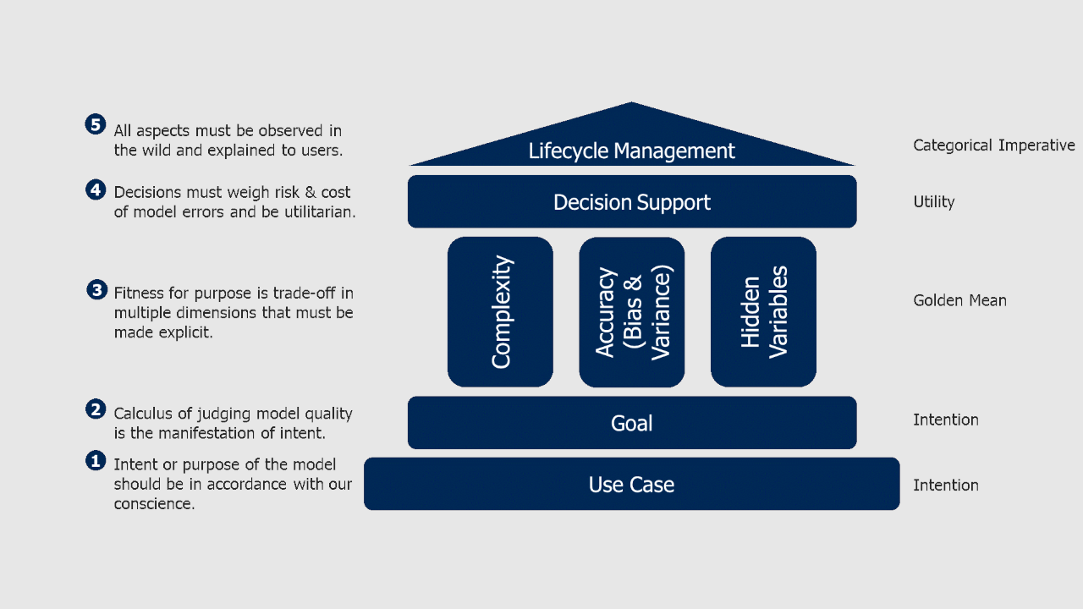
Figure 8. Collaboration and Ethical Respect Model

6.4 Ethical Responsibility in AI QA
My QA approach had a focus on ethical responsibility. I also ensured that data were collected in an ethically appropriate manner, evaluation metrics did not support bias, and the system was transparent on how to express uncertainty to its users. This strengthened the use of QA as a technical activity but also as a protection mechanism of responsible AI utilisation.

6.5 Reflection on Professional Values
This experience taught me that professional values do not just determine how we are going to carry out our tasks, but also the reason why we are going to carry out our tasks. My professional identity as a QA Engineer is based on accountability, integrity, and respect.

7. References
- Driscoll, J. (2007). Practising Clinical Supervision: A Reflective Approach for Healthcare Professionals. Elsevier Health Sciences.
- BCS Code of Conduct. (2023). Professional Conduct and Ethical Guidelines for Computing Professionals. British Computer Society.
- Amershi, S., et al. (2019). Guidelines for Human-AI Interaction. Proceedings of the 2019 CHI Conference on Human Factors in Computing Systems. ACM Press.
- Doshi-Velez, F., & Kim, B. (2017). Towards a Rigorous Science of Interpretable Machine Learning. arXiv preprint arXiv:1702.08608.
- Ribeiro, M. T., Singh, S., & Guestrin, C. (2016). “Why Should I Trust You?”: Explaining the Predictions of Any Classifier. Proceedings of the 22nd ACM SIGKDD Conference on Knowledge Discovery and Data Mining.
- Beizer, B. (1995). Software Testing Techniques. 2nd Edition. Dreamtech Press.
- Myers, G. J., Sandler, C., & Badgett, T. (2011). The Art of Software Testing. 3rd Edition. Wiley.
- Kaner, C., Falk, J., & Nguyen, H. Q. (1999). Testing Computer Software. 2nd Edition. Wiley.
- Bird, C., Nagappan, N., Murphy, B., Gall, H., & Devanbu, P. (2009). Don’t Touch My Code! Examining the Effects of Ownership on Software Quality. ESEC/FSE 2009.
- Lipton, Z. C. (2018). The Mythos of Model Interpretability. Communications of the ACM, 61(10), 36–43.

